EXP.NO: 2 Write JavaScript Programme to validate the

following fields of the HTML Registration page

DATE:

06/02/2025
AIM:
To write JavaScript code to validate user input in a registration form and ensure correct, valid data before submission.
ALGORITHM:
1. Input:
The user fills in the following fields: First Name, Password, E-mail, Mobile
Number, Last Name, and Address.
2. Validation Steps:
1. Validate First Name:
- Check if the first name contains only alphabets.
- Ensure the length of the First Name is at least 6 characters.
If any of these conditions fail, display an error message indicating the required input.
2. Validate Password:
- Check if the password is at least 6 characters long.
- If it is less than 6 characters, display an error message.
3. Validate E-mail:
- Use a regular expression to check if the email follows the standard pattern:
name@domain.com.
- Ensure that the email contains no invalid characters and matches the required
pattern.
- If it doesn’t match, display an error message indicating an invalid email
format.

4. Validate Mobile Number:
- Check if the mobile number contains exactly 10 digits.
- Ensure there are no alphabets or special characters.
- If the number is invalid, display an error message indicating the correct
format.
5. Validate Last Name:
- Ensure the Last Name field is not empty.
- If it is empty, display an error message.
6. Validate Address:
- Ensure the Address field is not empty.
- If it is empty, display an error message.
CODE:
<!DOCTYPE html>
<html lang="en">
<head>
<meta charset="UTF-8">
<title>Donor Registration</title>
<style>
body {
margin: 0;
font-family: Arial, sans-serif;
background: linear-gradient(to right, #8e0e00, #1f1c18);
}
.header {
text-align: center;
padding: 30px;
color: white;
}
.section {
background: white;
margin: 25px auto;
padding: 20px;
width: 90%;
max-width: 500px;
border-radius: 15px;
}
.form-box {
max-width: 420px;
margin: auto;
}
input, textarea {
width: 100%;
padding: 10px;
margin: 8px 0;
border-radius: 6px;
border: 1px solid #ccc;
}
textarea {
resize: none;
height: 60px;
}
button {
width: 100%;
padding: 12px;
background: #b31217;
color: white;
border: none;
border-radius: 6px;
font-size: 16px;
}
</style>
<script>
function validateForm() {
var fname = document.getElementById("fname").value.trim();
var lname = document.getElementById("lname").value.trim();
var password = document.getElementById("password").value;
var email = document.getElementById("email").value.trim();
var mobile = document.getElementById("mobile").value.trim();
var address = document.getElementById("address").value.trim();

var namePattern = /^[A-Za-z]+$/;
var emailPattern = /^[a-zA-Z0-9._]+@[a-zA-Z]+\.[a-zA-Z]{2,}$/;
var mobilePattern = /^[0-9]{10}$/;

if (!namePattern.test(fname) || fname.length < 6) {
alert("First Name must contain alphabets only and minimum 6 characters.");
return false;
}
if (lname === "") {
alert("Last Name cannot be empty.");
return false;
}
if (password.length < 6) {
alert("Password must be at least 6 characters long.");
return false;
}
if (!emailPattern.test(email)) {
alert("Invalid Email ID (name@domain.com).");
return false;
}
if (!mobilePattern.test(mobile)) {
alert("Mobile Number must contain exactly 10 digits.");
return false;
}
if (address === "") {
alert("Address cannot be empty.");
return false;
}
alert("Registration Successful! Thank you for donating blood ❤️");
return true;
}
</script>
</head>
<body>
<div class="header">
<h1>Donor Registration</h1>
</div>
<div class="section">
<div class="form-box">
<form onsubmit="return validateForm()">
<input type="text" id="fname" placeholder="First Name">
<input type="text" id="lname" placeholder="Last Name">
<input type="password" id="password" placeholder="Password">
<input type="text" id="email" placeholder="Email ID">
<input type="text" id="mobile" placeholder="Mobile Number">
<textarea id="address" placeholder="Address"></textarea>
<button type="submit">Register</button>
</form>
</div>
</div>
</body>
</html>
OUTPUT:
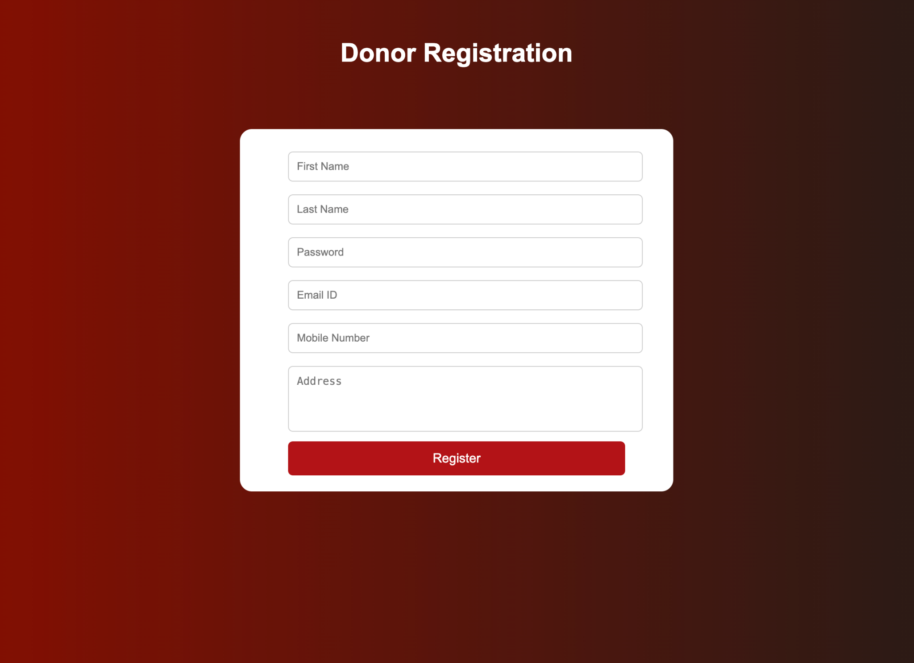
RESULT:
HTML page with Form is created and is validated using Javascript

